**Instructions:**Replace **[bracketed red text]** with the requested information or screen capture.  
Replace **bracketed red text with black text**.  
**PLEASE do not include full page, full window screen shot images**, or full screen shots that have been reduced in size.   
Use a snippet tool to capture parts of the screen and insert those images into the template.  
**Do not remove tags from this template. An example of a tag is [C01]. All fields are required.***Please do not alter template formatting or delete parts of this template.*

Part A - Student Information: [A]  
 **1. Student Name: [STUDENT NAME – Aamir, Patel]**

**2. What day and date did you start this tutorial? [3/10/2021 - Wednesday]**

Go back to the instructions and continue with Part B.Part B – Shared Webhost Information: [B]

**1. Which shared web host did you use for this part of the assignment?** **[Web Host Name Here]**

**2. Pantheon – Did you build a Pantheon Drupal site?   
[Yes or No]**

Enter your shared web host Drupal site information below:   
  
B.1 New Drupal Site on your Shared Web Host:

1. Shared Web Host account username: [B.1.1]  
   [ Aamir8567]
2. Shared web host account password: [B.1.2]  
   [ Kamboli90123! ]
3. **Assignment Website In-Directory Name:** [B.1.3]   
   **[** tutorial09 **]**
4. **Assignment MySQL Database Information** [B.1.4]
   * **Database Name:** **[ drup788]**
   * **Table Prefix:** **[ dr6e_ ]**
5. **WEBSITE Admin Username:** [B.1.5] **[aapadcpate]**
6. **WEBSITE Admin Password:** [B.1.6] **[9aIwR@LZB%#uk9Fgh3]**
7. **Tutorial Website URL:** [B.1.7] **[https://aamirpatel.tech/tutorial09/]**
8. SCREEN CAPTURE – Backend Account Settings, REGISTRATION AND CANCELLATION  
   Admin toolbar > Configuration > Account settings, Registration and Cancelation[B.1.8]   
   [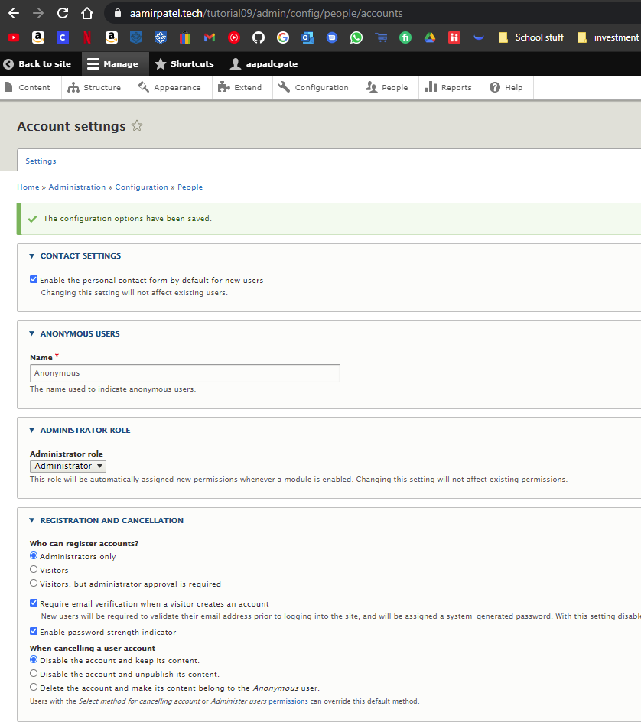]

Go back to the instructions and continue with Part C.

B.2 -OR- if you used Pantheon (PA) fill out the information below:

1. **Pantheon Account Info:** [B.2.1]
   * **Pantheon Account Email: [Your Pantheon Account Email]**
   * **Pantheon Password: [Your Pantheon Account Password]**
2. **Drupal Version major.minor.patch:** [B.2.2] **[Drupal Version]**
3. **Pantheon Site Name:** [B.2.3] **[SITE NAME]**
4. **WEBSITE Admin Username:** [B.2.4] **[ADMIN USERNAME]**
5. **WEBSITE Admin Password:** [B.2.5] **[ADMIN PASSWORD]**
6. **Pantheon site URL:** [B.2.6] **[Your Pantheon CMS Site URL]**
7. SCREEN CAPTURE – Backend Account Settings, REGISTRATION AND CANCELLATION  
   Admin toolbar > Configuration > Account settings, Registration and Cancelation[B.2.7]   
   [SCREEN CAPTURE HERE]

Go back to the instructions and continue with Part C.

Part C – Extending Drupal with Blocks

1. What is a block as it relates to Drupal? Write a few sentences on what blocks are what they are used for on Drupal sites.[C.1]   
   [ Blocks in durpal are a box of content in a specific region of a webpage, that is supported by the theme. You can manage them to display certain items to specific users’ types, and specific pages.]
2. What are theme block regions as they relate to Drupal? Write a few sentences on what theme regions are and the two different ways you can see what theme block regions exist on a Drupal theme. [C.2]   
   [Theme block regions are specific pre designed regions in a theme where you can place your blocks into. The two ways you can access those regions is Block Layouts section, which gives you a list of block sections. Or you can use Demonstrate block region, which is a visual representation of all the regions.]
3. SCREEN CAPTURE – Backend list of Block layouts   
   Admin toolbar > Structure > Block Layouts, with the Sidebar First and Second visible on your screen capture [C.3]   
   [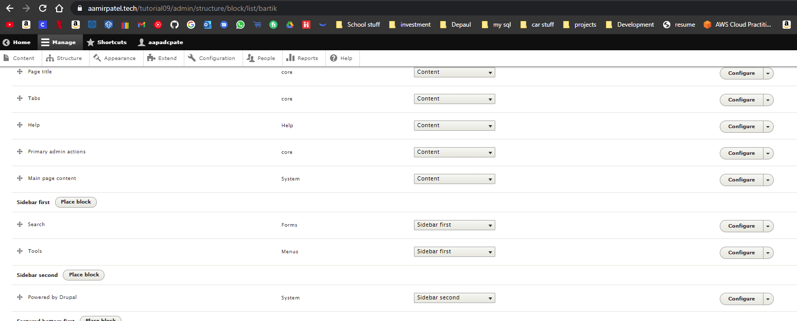]
4. SCREEN CAPTURE – Front-end screen capture showing the blocks we added  
   [C.4]   
   [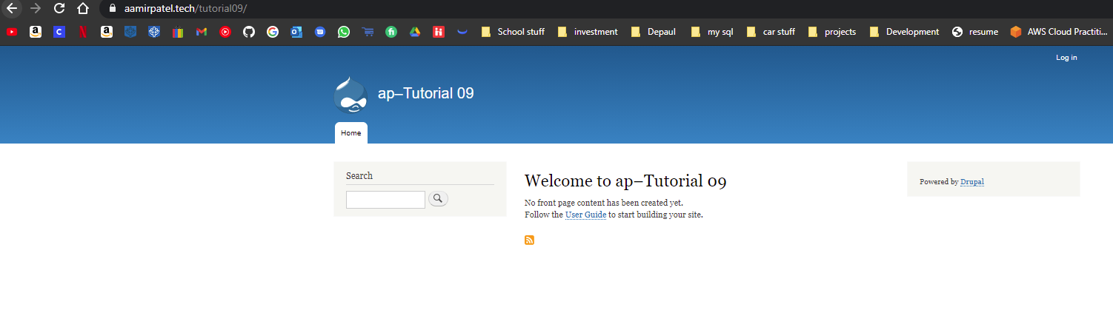]

Go back to the instructions and continue with Part D.

Part D – Extending Drupal with Taxonomy + Vocabulary + Terms

Shared Web Host Drupal Screen Captures:

1. SCREEN CAPTURE – Backend Taxonomy List of 4 Vocabularies we created.   
   Admin toolbar > Structure > Taxonomy [D.1]   
   [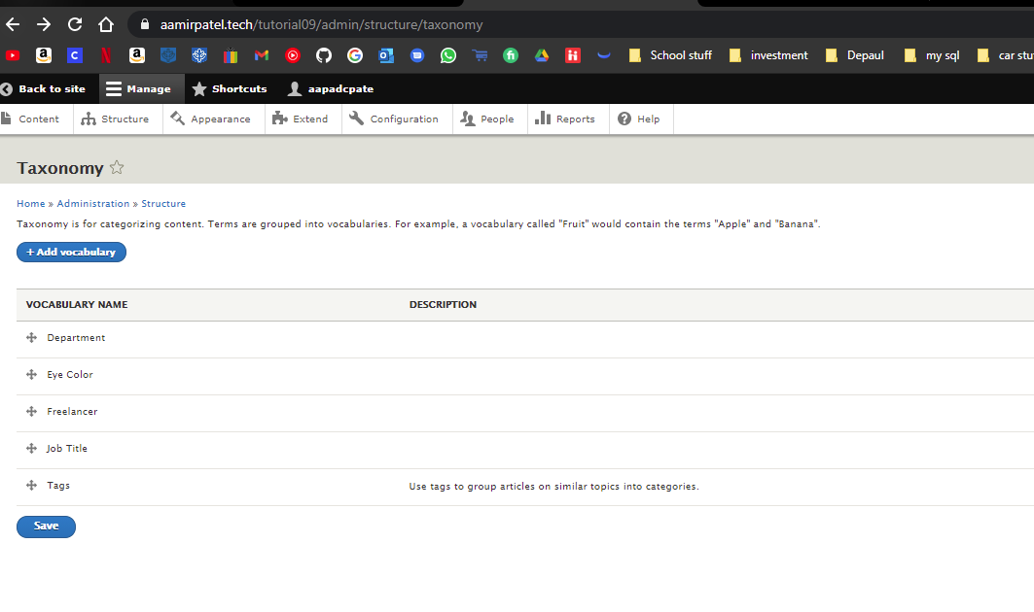]
2. SCREEN CAPTURE – Backend Term list of each Vocabulary  
   Admin toolbar > Structure > Taxonomy > Select List Terms for Freelance Vocabulary Name[D.2]   
   [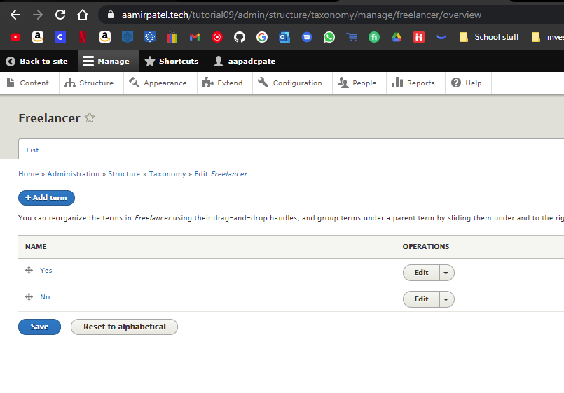]
3. SCREEN CAPTURE – Backend Term list of each Vocabulary  
   Admin toolbar > Structure > Taxonomy > Select List Terms for Department Vocabulary Name[D.3]   
   [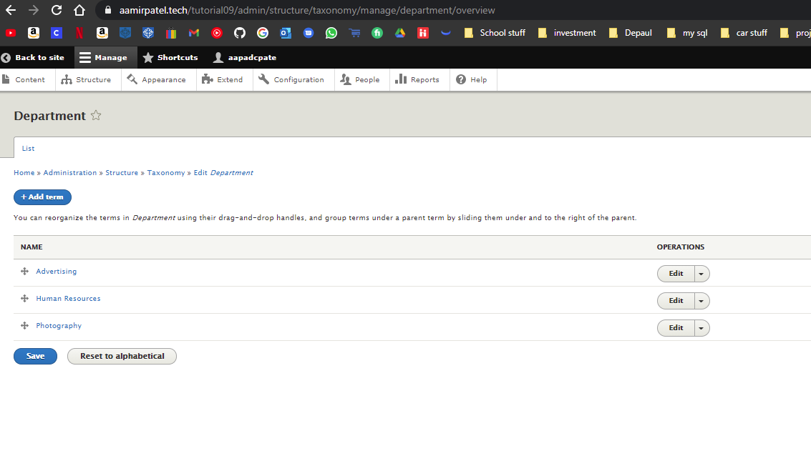]
4. SCREEN CAPTURE – Backend Term list of each Vocabulary  
   Admin toolbar > Structure > Taxonomy > Select List Terms for Eye Color Vocabulary Name[D.4]  
    [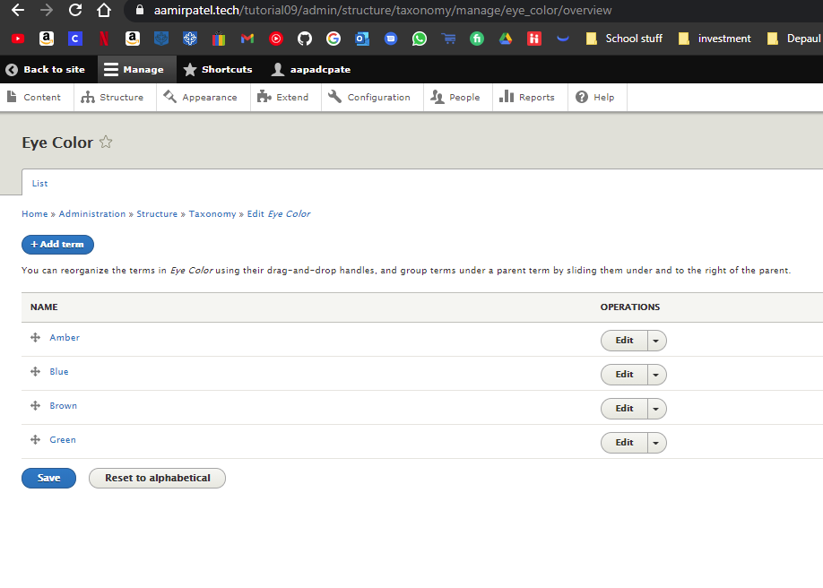]
5. SCREEN CAPTURE – Backend Term list of each Vocabulary  
   Admin toolbar > Structure > Taxonomy > Select List Terms for Job title Vocabulary Name[D.5]   
   [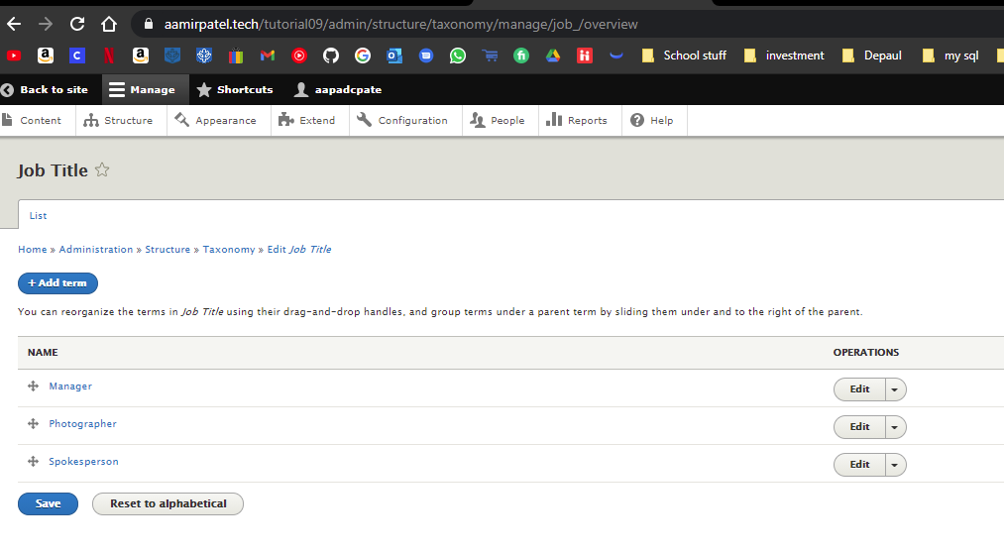]

Go back to the instructions and continue with Part E.

Part E - Extending Drupal with Custom Content Types

1. SCREEN CAPTURE – Backend TABS for the “My Employee” content type  
   Admin toolbar > structure > Content types, select “Edit” TAB for “My Employee”   
   [E.1]   
   [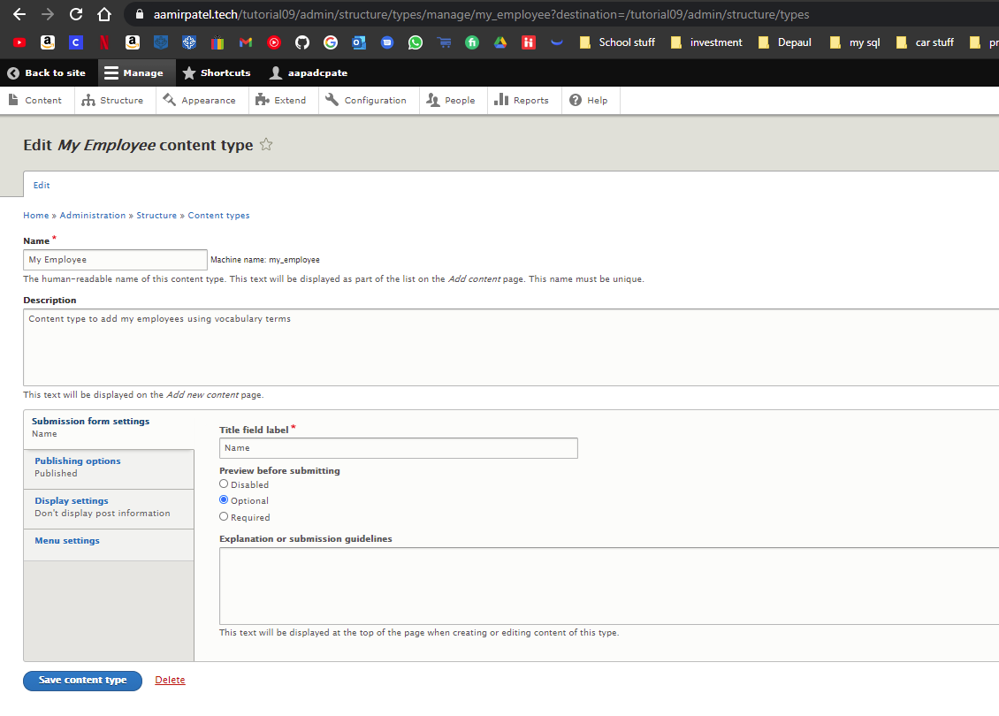]
2. SCREEN CAPTURE – Backend TABS for the “My Employee” content type  
   Admin toolbar > structure > Content types, select “Manage fields” TAB for “My Employee”   
   [E.2]   
   [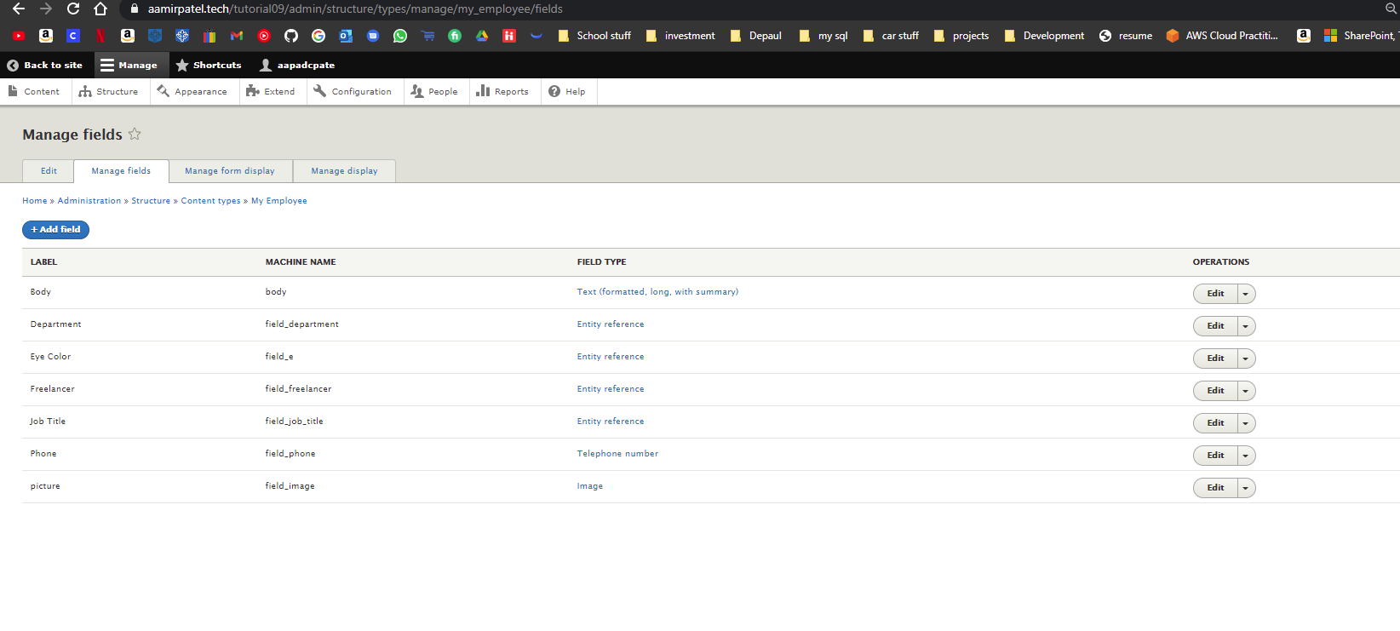]
3. SCREEN CAPTURE – Backend TABS for the “My Employee” content type  
   Admin toolbar > structure > Content types, select “Manage form display” TAB for “My Employee”   
   [E.3]   
   [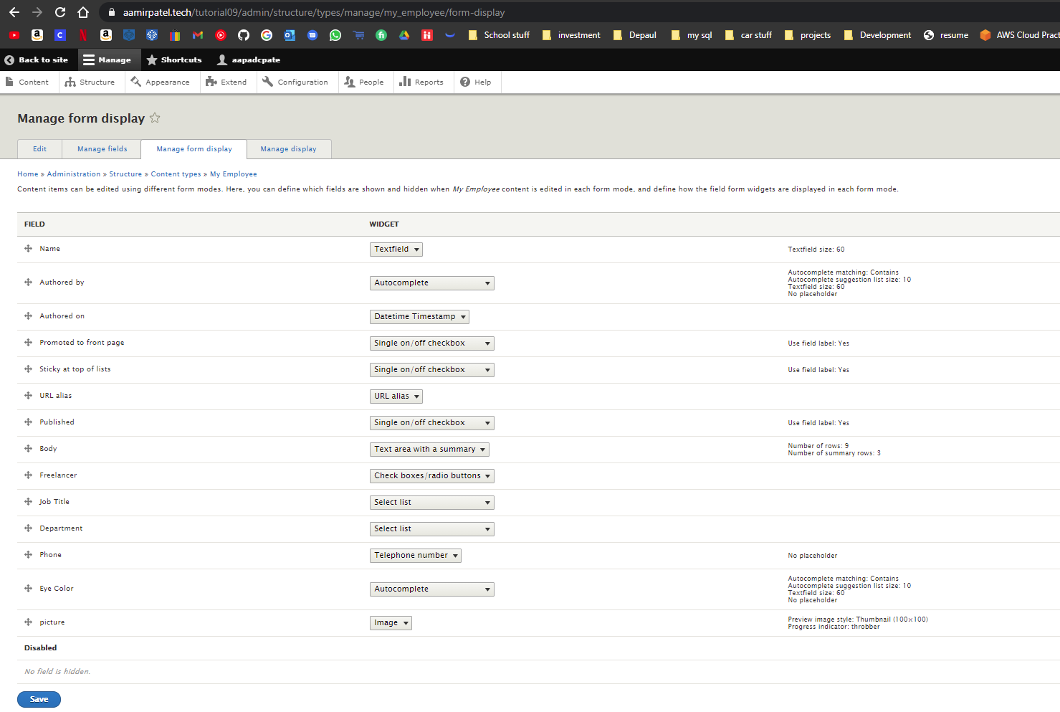]
4. SCREEN CAPTURE – Backend TABS for the “My Employee” content type  
   Admin toolbar > structure > Content types, select “Manage display” TAB for “My Employee”   
   [E.4]   
   [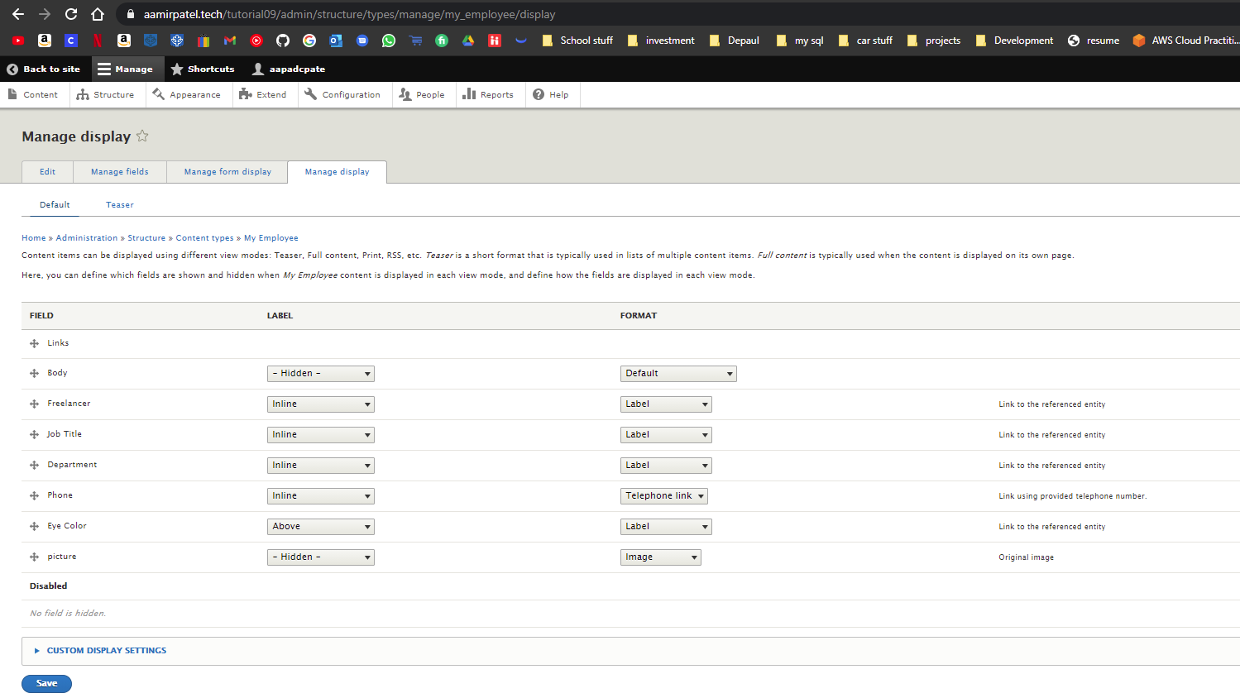]

Go back to the instructions and continue with Part F.

Part F - Create nodes of My Employee custom content type

1. SCREEN CAPTURE – Backend list “My Employee” nodes  
   Admin toolbar > Content, Filter content by Product “My Employee” before taking screen capture[F.1]   
   [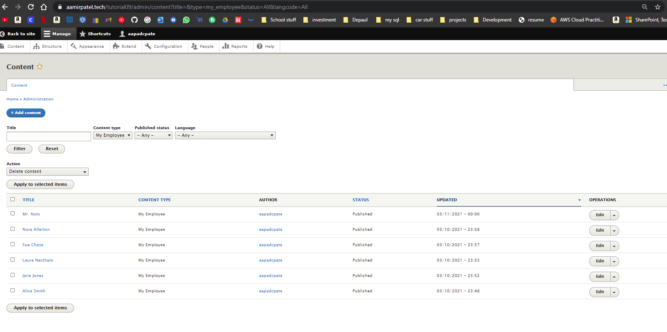]

Go back to the instructions and continue with Part G.

Part G – Extending Drupal with Views

1. SCREEN CAPTURES – Backend Views List page  
   Admin toolbar > Structure > Views with the three names of the “My Employee views” we created visible on the screen capture.  
   [G.1]   
   [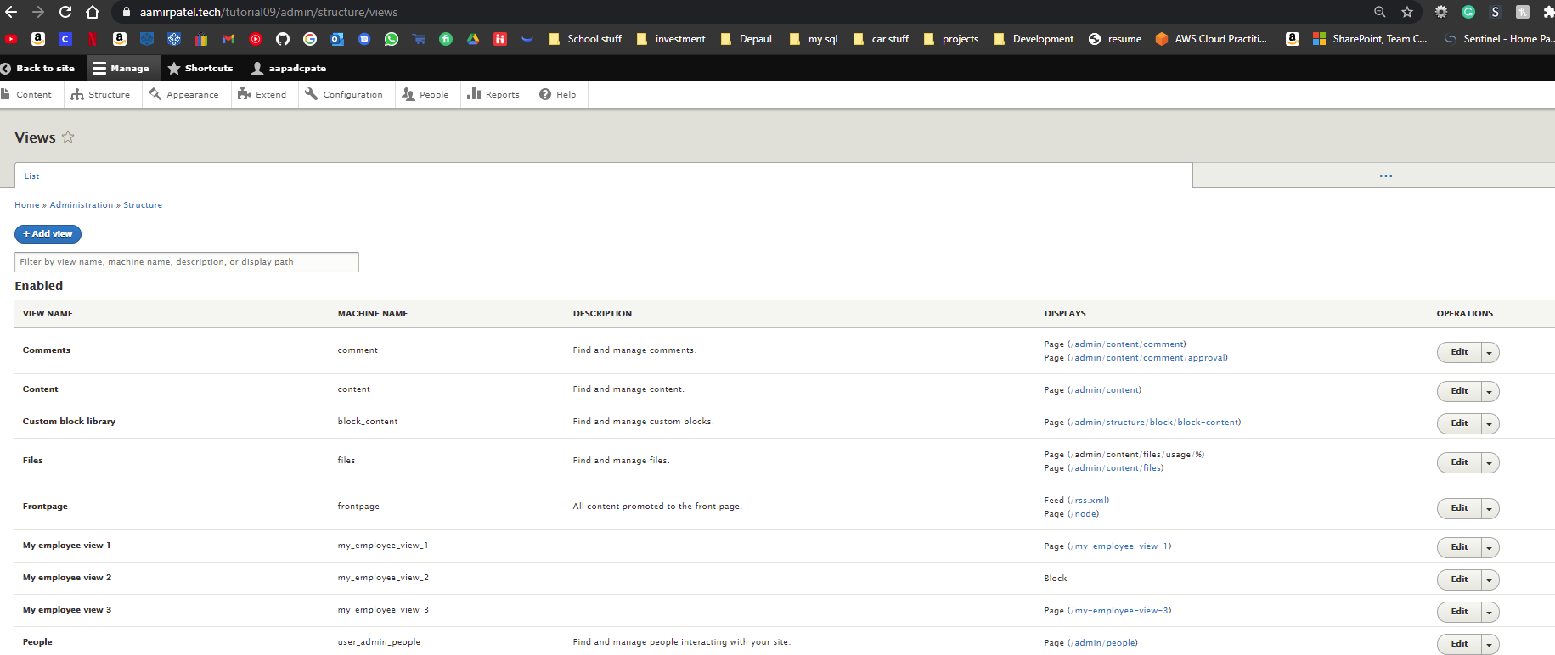]
2. SCREEN CAPTURES – Backend View summary of an “My employee view 1”  
   Admin toolbar > Structure > Views, select an Employee view  
   [G.2.1]   
   [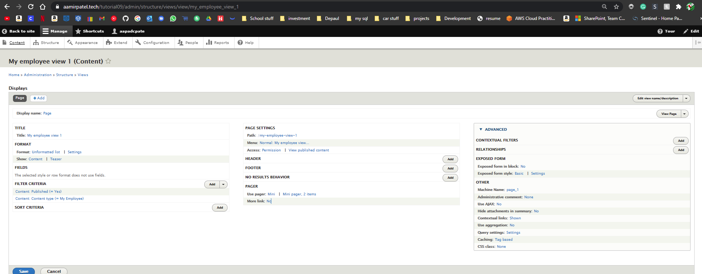]   
   [G.2.2]   
   [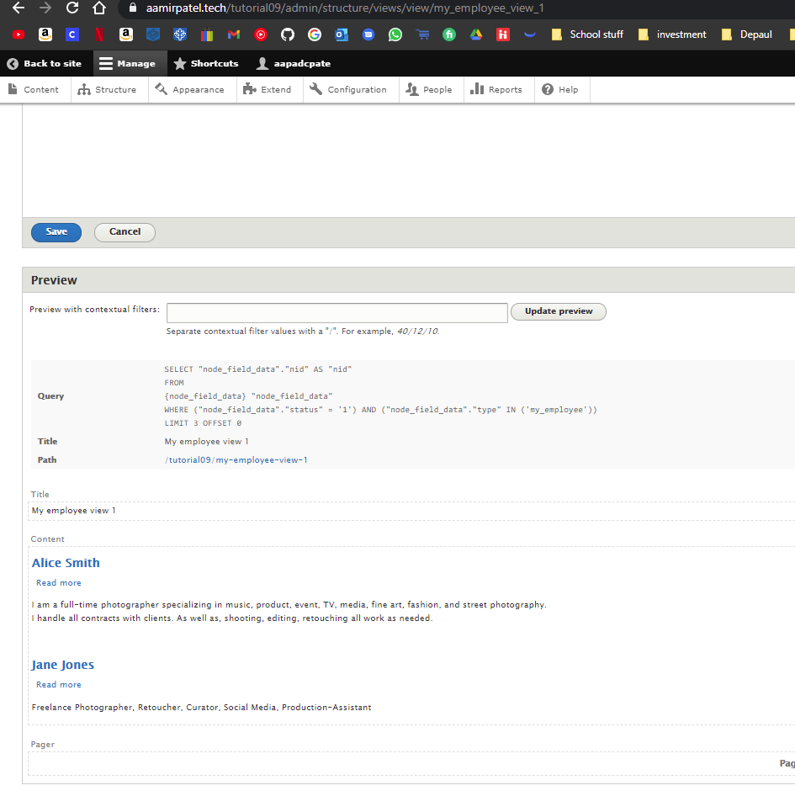]
3. SCREEN CAPTURES – Backend View summary of an “My employee view 2”  
   Admin toolbar > Structure > Views, select an Employee view  
   [G.3.1]   
   [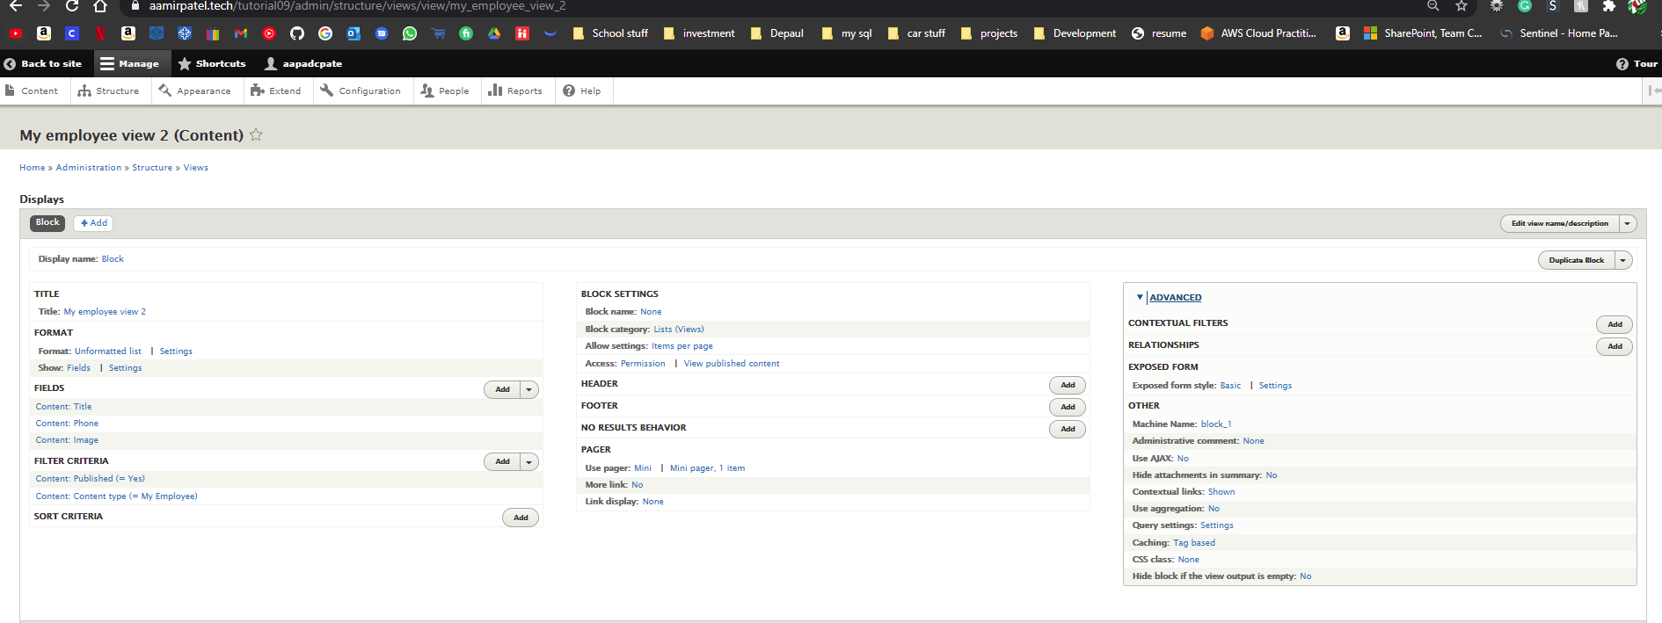]   
   [G.3.2]   
   [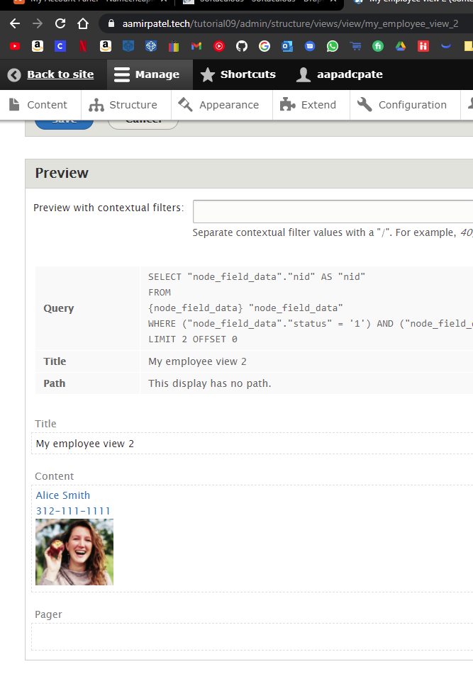]
4. SCREEN CAPTURES – Backend View summary of an “My employee view 3”  
   Admin toolbar > Structure > Views, select an Employee view  
   [G.4.1]   
   [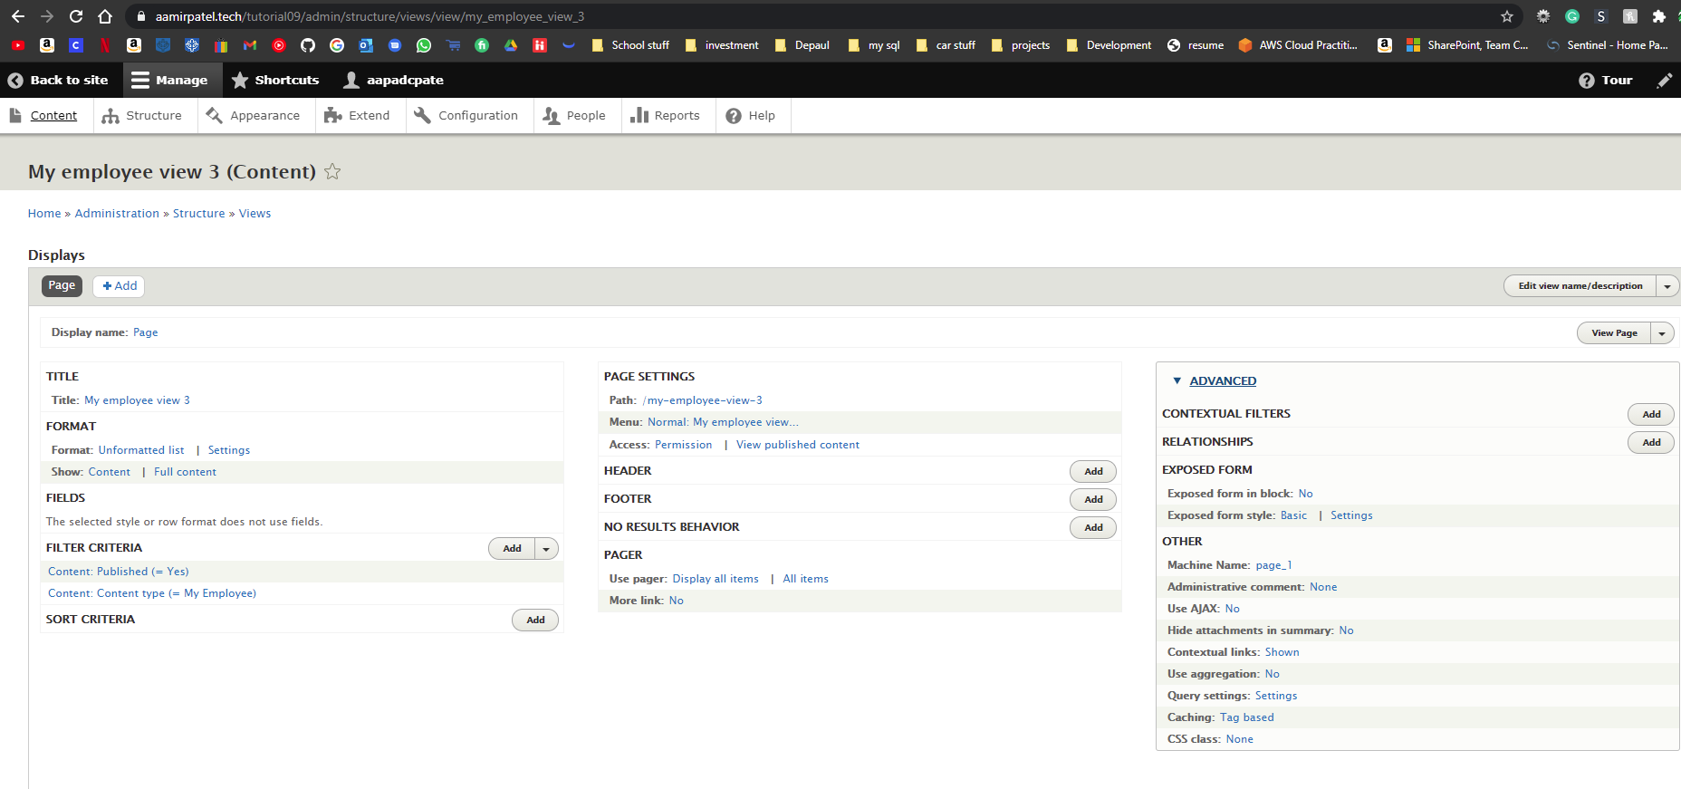]   
   [G.4.2]   
   [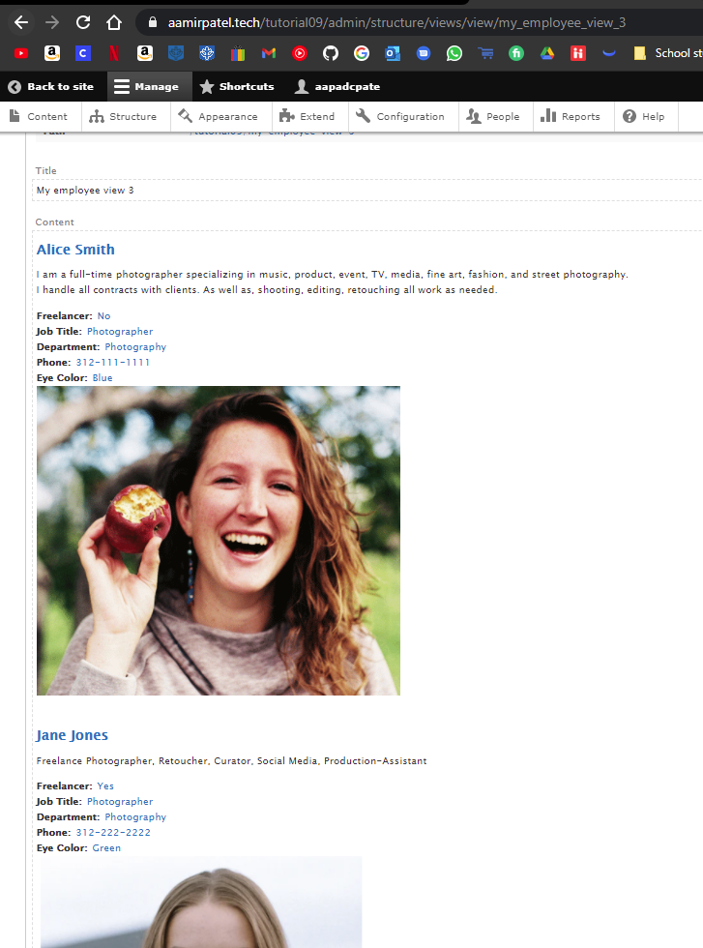]

Go back to the instructions and continue with Part H.

Part H – Drupal JavaScript Library Install

1. For Shared Web Host (SWH):

SCREEN CAPTURE – cPanel File Manager with Drupal site folder expanded and the libraries folder visible with the four (4) new JS Library folders and their uploaded zip files  
[H.1-Shared-Web-Host]   
[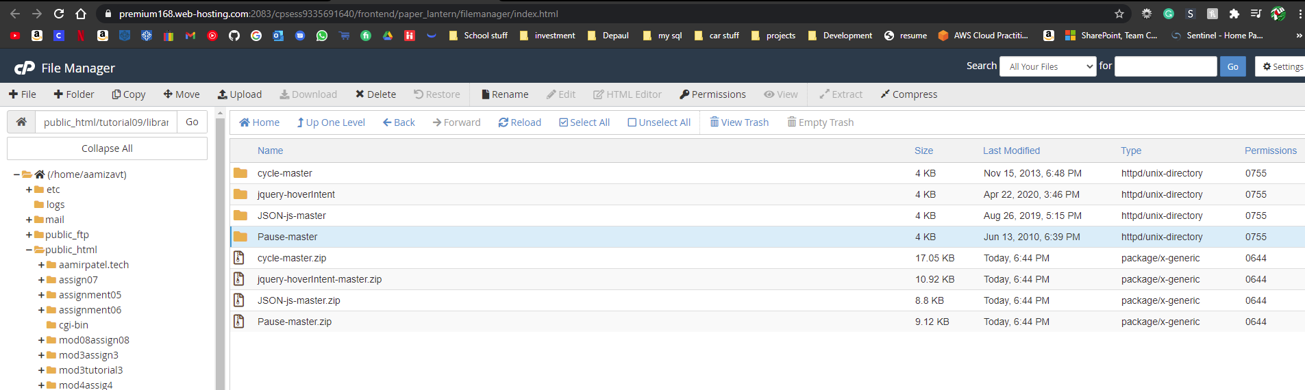]

1. For Pantheon (PaaS):

SCREEN CAPTURE – FileZilla destination (sever) folder with Drupal site folder expanded and the libraries folder visible with the four (4) new JS Library folders and their uploaded zip files [H.2-Paas]  
[SCREEN CAPTURE HERE]

1. For Codeanywhere:  
   SCREEN CAPTURE – Fully expanded Drupal root folder with the libraries folder visible with the four (4) new JS Library folders and their uploaded zip files  
   [H.3-Codeanywhere]  
   [SCREEN CAPTURE HERE]

Go back to the instructions and continue with Part I.

Part I – Install the Drupal Views Slideshow Module

1. For Shared Web Host (SWH):

BACKEND SCREEN CAPTURE – Admin toolbar > Extend, scroll down to View section and stake a screen capture of the enabled VIEWS section items. Please make sure the web browser address bar is visible on your screen capture for credit.   
[I.1-Shared-Web-Host]   
[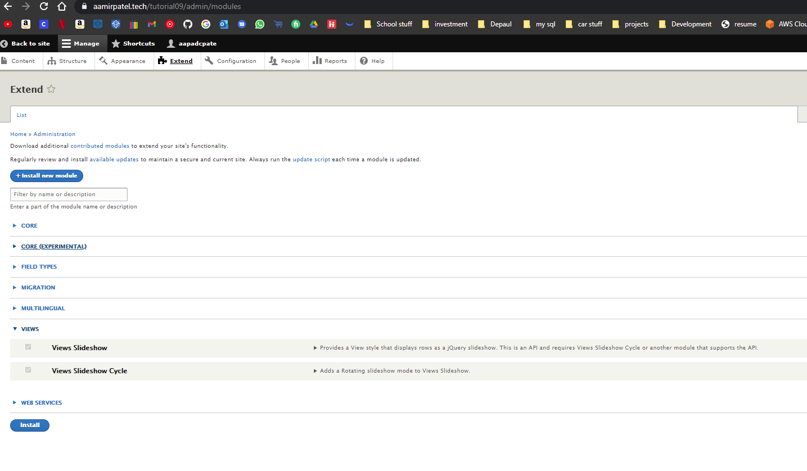]

1. For Pantheon (PaaS):

BACKEND SCREEN CAPTURE – Admin toolbar > Extend, scroll down to View section and stake a screen capture of the enabled VIEWS section items. Please make sure the web browser address bar is visible on your screen capture for credit.   
[I.2-Paas]  
[SCREEN CAPTURE HERE]

1. For Codeanywhere:  
   BACKEND SCREEN CAPTURE – Admin toolbar > Extend, scroll down to View section and stake a screen capture of the enabled VIEWS section items. Please make sure the web browser address bar is visible on your screen capture for credit.   
   [I.3-Codeanywhere]  
   [SCREEN CAPTURE HERE]

Go back to the instructions and continue with Part J.

Part J – Create Custom Content Type and implement Views Slideshow

1. Front-end SCREEN CAPTURES [J.1]

Take three (3) screen captures of the front end of your website, the screen captures are of the three (3) slides in the slideshow.

[J.1.1]  
[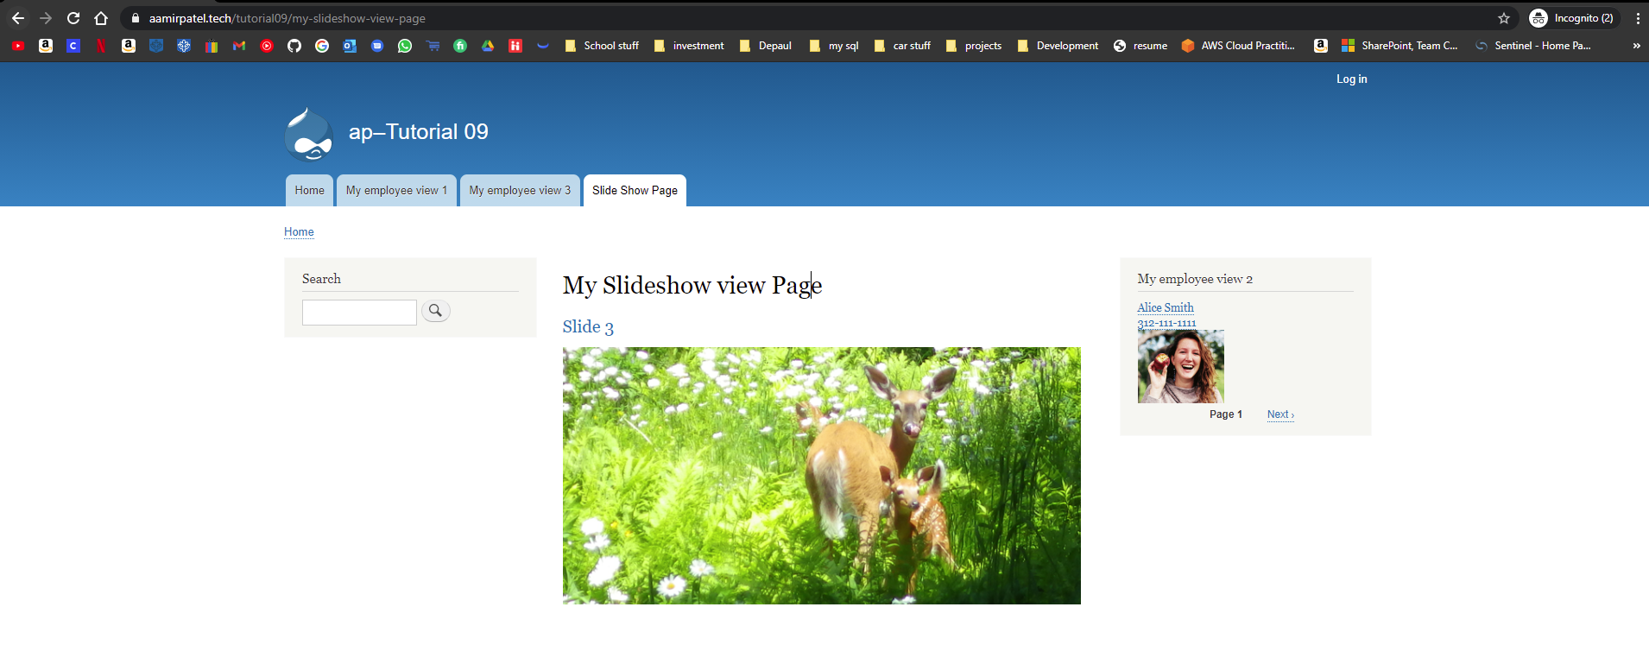]

[J.1.2]  
[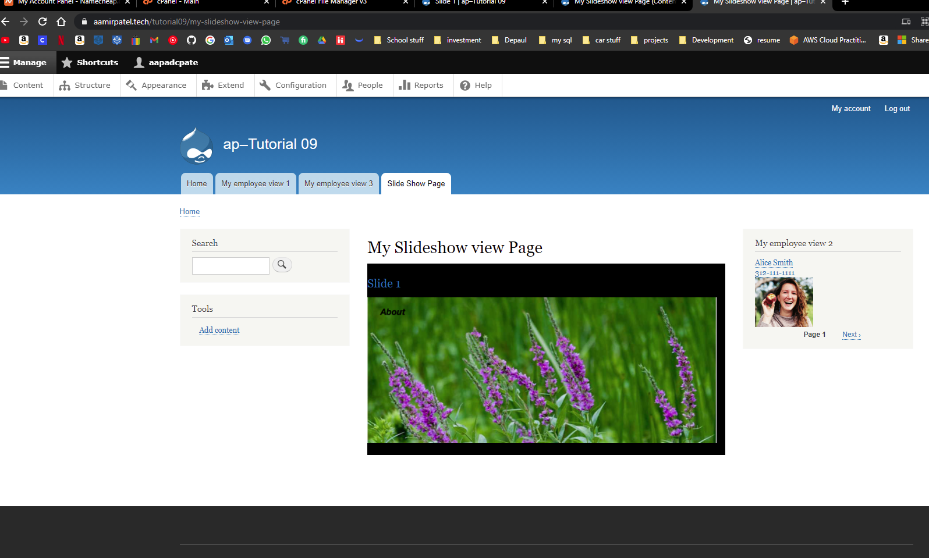]

[J.1.3]  
[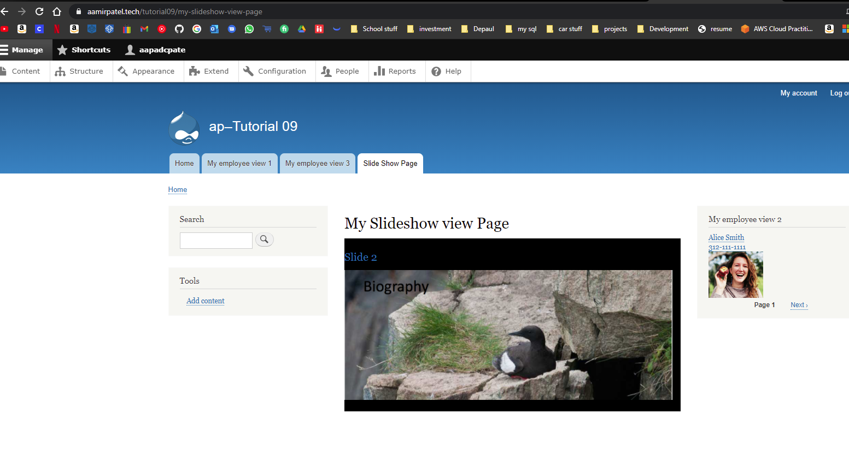]

1. BACKEND SCREEN CAPTURE – Admin toolbar > Structure > Content types > My Slide   
   Take screen captures, left to right, starting with Edit, of the four TABS.   
   Please make sure the web browser address bar is visible on your screen capture for credit.   
   [J.2.1]  
   [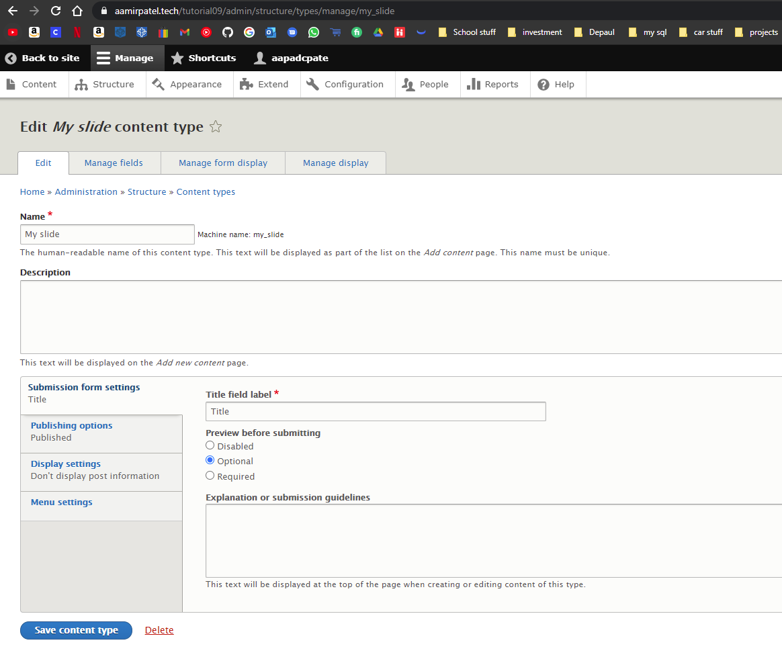]

[J.2.2]  
[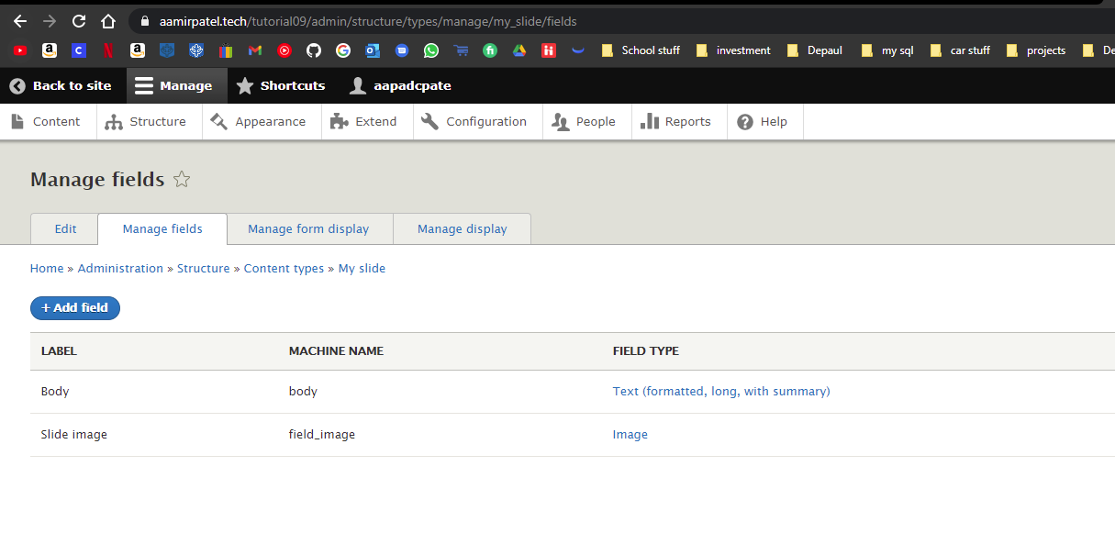]

[J.2.3]  
[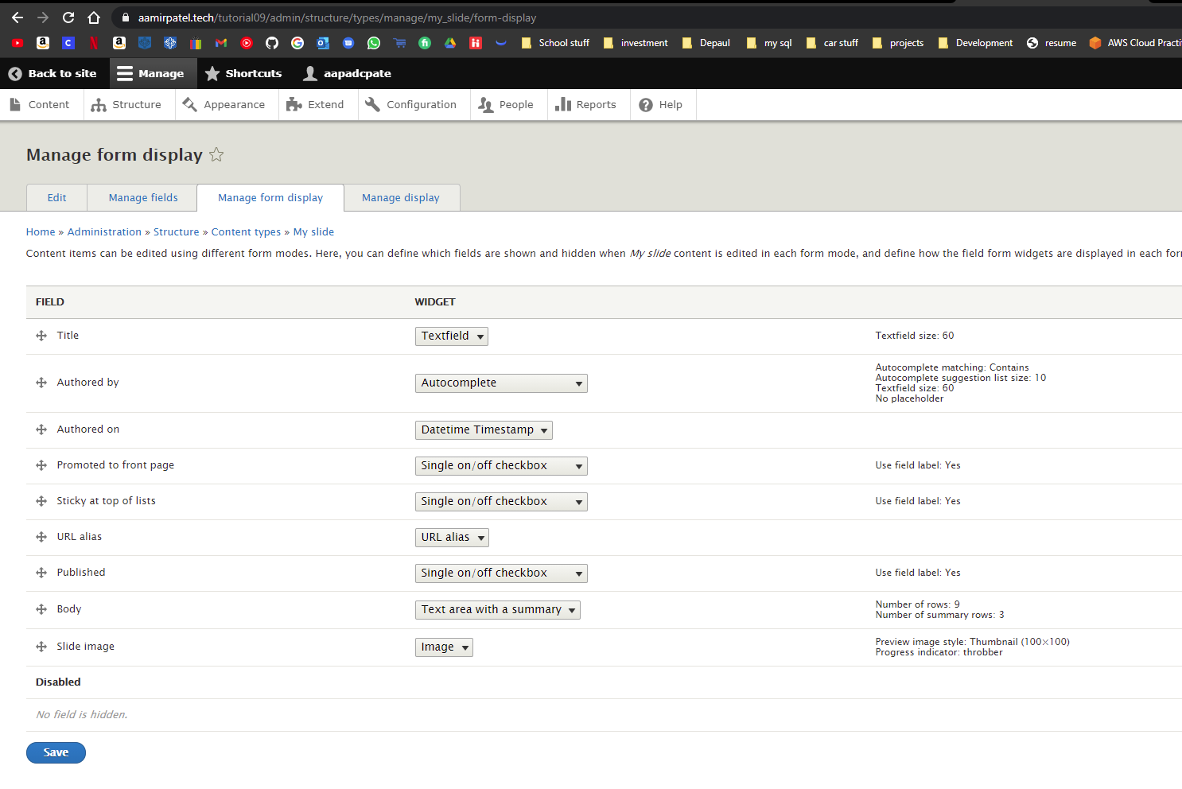]

[J.2.4]  
[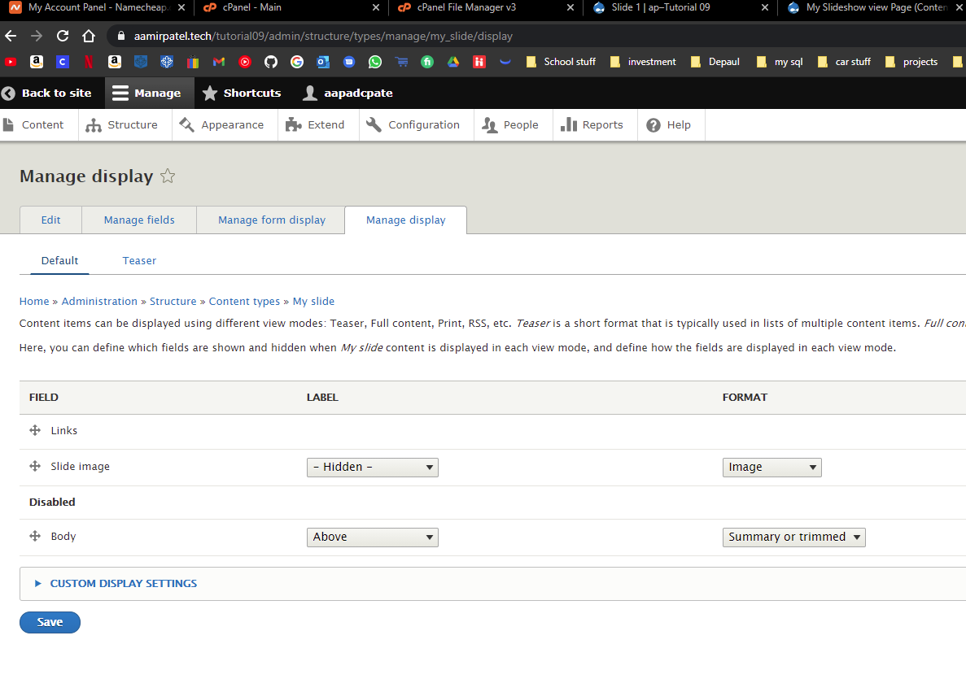]

1. BACKEND SCREEN CAPTURE of the “My Slideshow” View summary page  
   Admin toolbar > Structure > Views > My Slideshow view  
   Take screen captures to capture the whole view summary page. This may take 2 or 3 captures.   
   Please make sure the web browser address bar is visible on your screen capture for credit.   
   [J.3]  
   [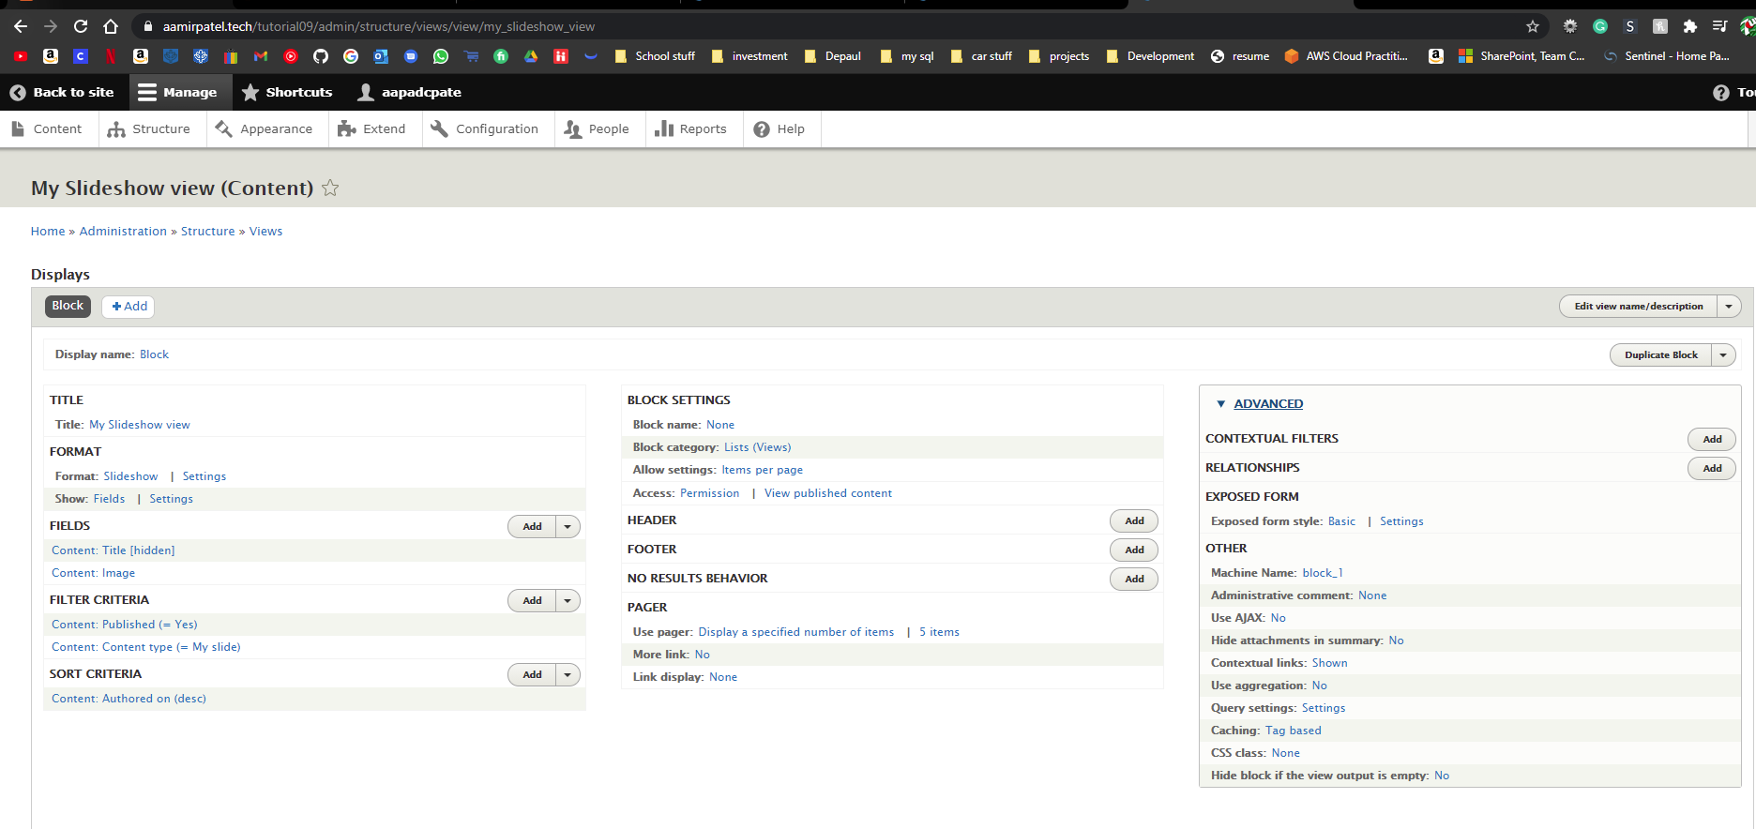]

[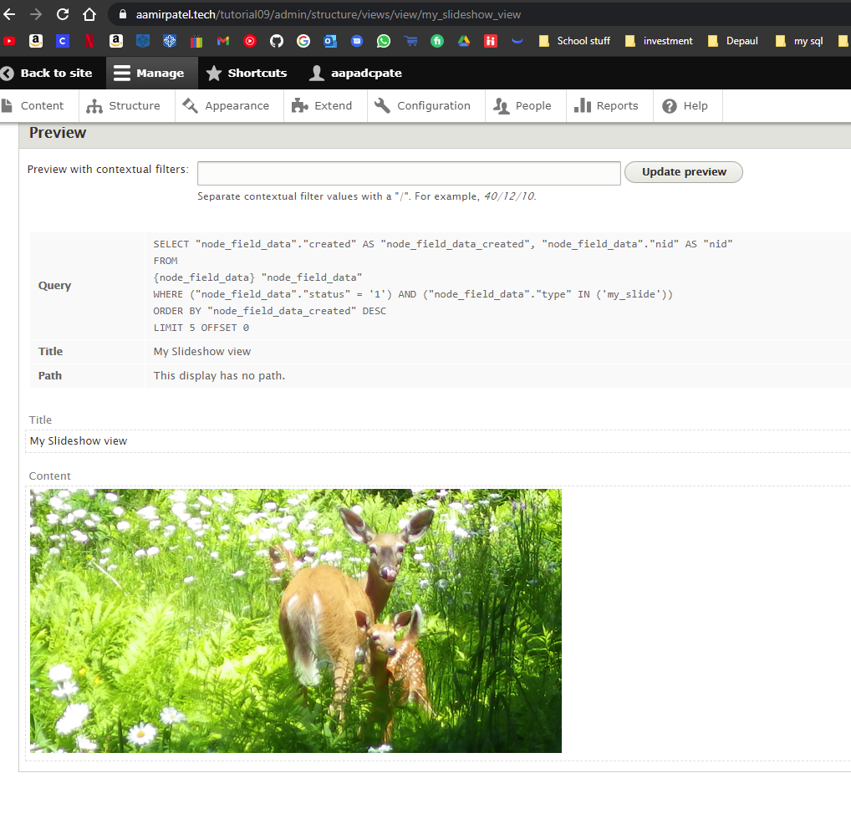]  
[View Summary Page Capture - 2]

Go back to the instructions and continue with Part K.

* I was having issues with the slide show, I created the slideshow block but it would not work as a block. To troubleshoot I created a page instead, that seemed to work, however that only works in the admin view, and does not work in the user view. So I ended up creating a page for the slideshow.